- Changes in Overview Dashboard
- Filters: for example, Time Period, Region, Sales Representative, Industry
- All the tiles should have a reference to some time period, for example, compared to last quarter, last year etc, or in reference to some relevant value from past quarter, year etc.
- 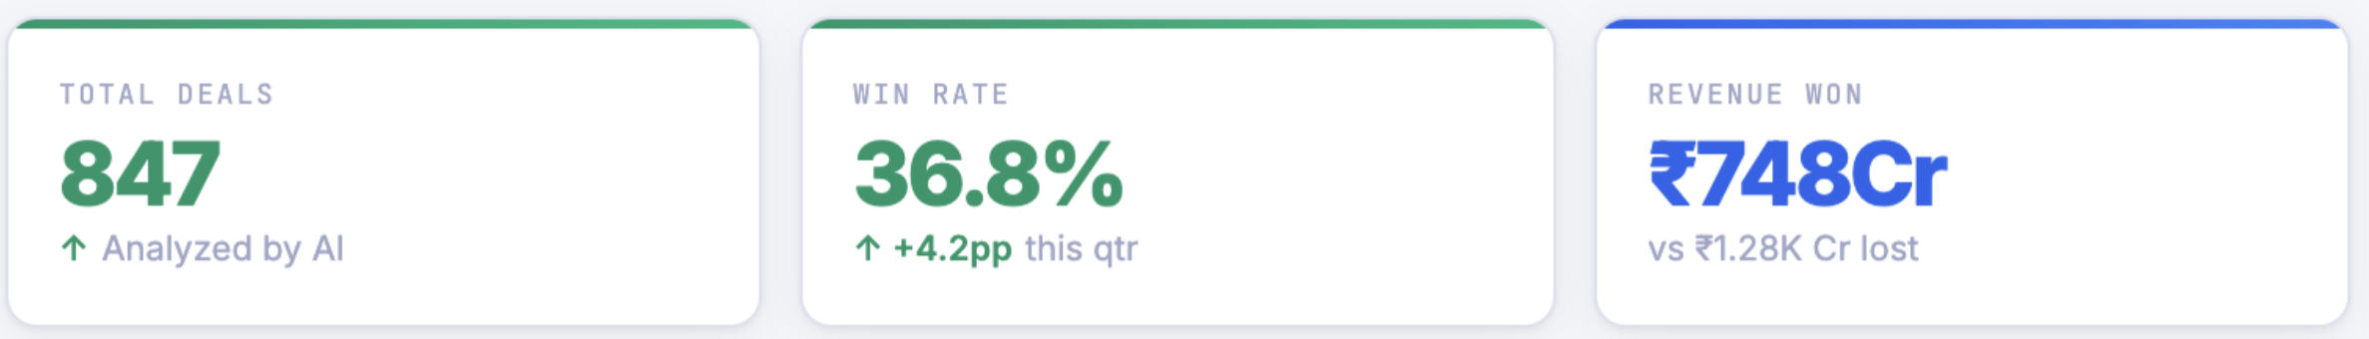
- Replace real values from backend data,., instead of something like “Choose competitor’s brand”
- 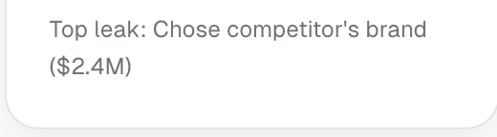
- Include Top win reasons too with Top lose reasons
- In the “Recent Deals” table, include reason of win or loss column

- Win/Loss Analysis page
  - Include relevant filters
  - In tabs like Industry, Deal Size etc, include Geography
  - In all bar graphs, show the labels upfront beautifully.
  - I need to show the identified patterns in (and other parameters you think are relevant). Show the proof as explanations from the conversations. What could we improve in this over what we have build till now?
    - Industry
    - Deal size
    - Sales cycle length
    - Competitor mentions
    - Objection themes
    - Builds a refined Ideal Customer Profile (ICP)
    - Suggests positioning improvements
  - Depending upon the point #d , give actionable insights.
- 